6 pictures and 6 stories
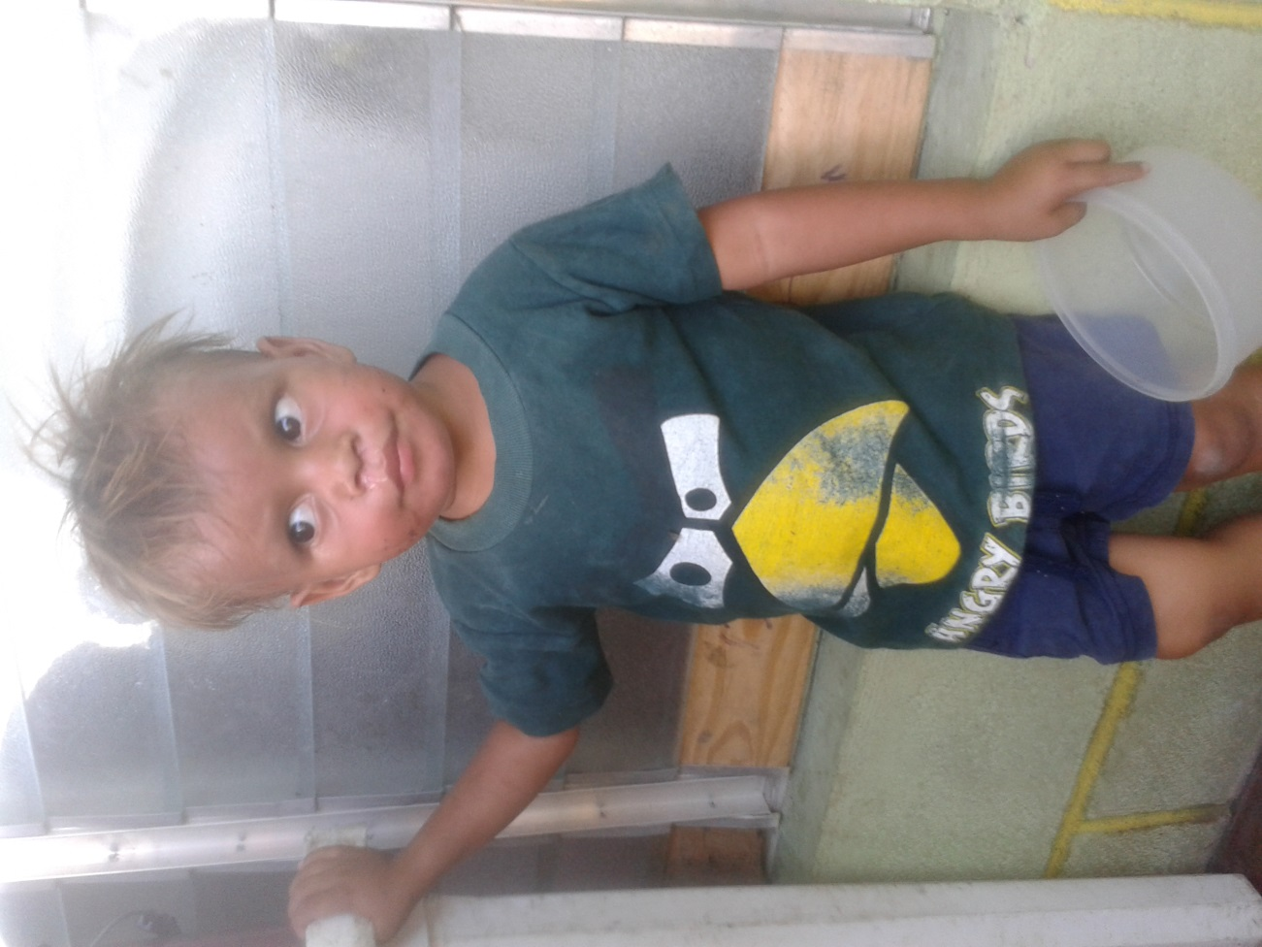
Denis IS AN INIGMA. No one really knows how hold he is or really who his family is. All the children say he´s their little brother. He kind of lives from house to house in Via Guadelupe, (the resettlement colony from the city garbage dump. Denis has been our most regular attendee at the feeding center. He´s been coming ever since we started. I have never heard a word out of his mouth, nor has anyone else for that matter. He doesn´t sing, doesn´t smile, doesn´t laugh. He just sneaks up to the feeding line, with or without clothes ever since he has been able to talk. I am praying that we can bring him into the Jim Winner Home or at least in the Pure Heart PreK. I would love to hear his story someday, so would the rest of us as well!
Angelica on any other planet would be a homecoming queen, student council president, cheerleader and valedictorian. She would be in the running for scholarships at any ivy league school. She could enjoy the future of a brilliant corporate lawyer or surgeon. But, alas, her world, her planet just so happens to be in the poorest neighborhood in the 2nd to the poorest nation in the western hemisphere. She has dreams. She has a stupendous personality. She is witty, funny, charming, kind, good, moral, obedient and respectful. She is the leader of the kids her. She never fights, never argues, never gets visably mad, even though the hunger, mosquitos, fire ants, rodents, sicknesses, heat, air pollution, stench and humidity here is usually at the level of unbearable or worse.
On another planet, her future would be very bright. She´s eloquent, beautiful, charming and really really funny. On this planet, Angelica´s future is very bleak.
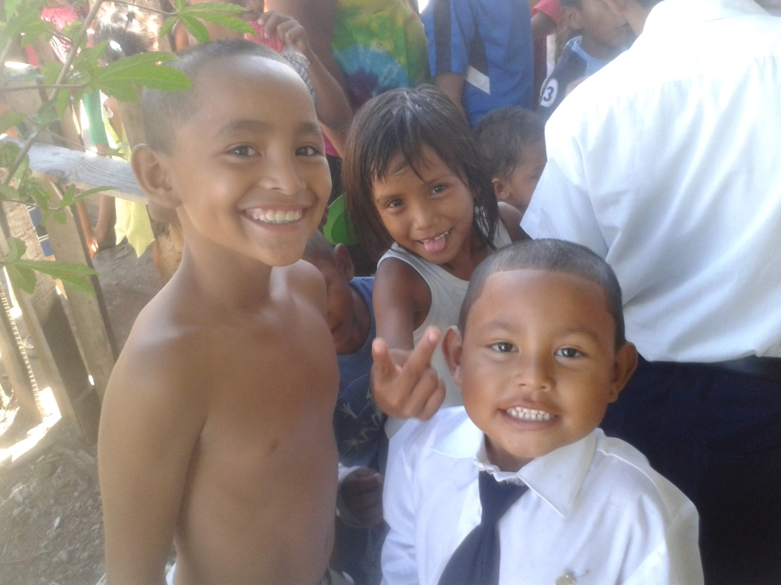
El Presidente, and his little brother, enano. I have the terrible habit of nicknaming kids. Fortunately, I have the GOOD habit of always seeing the best in these kids. El President has a smile that will not quit. He loves everyone. Everyone loves him. People follow him and respect him. I made the mistake of calling him ´El Presidente´. He liked it and so does everyone else, so he´s stuck with it. I forgot his real name. So has everyone else. I have never seen him loose his cool, when in the same situation I might have lost my cool on several events. He always is ready to help others. He always helps Winnie. Freely, happily and full of good cheer.
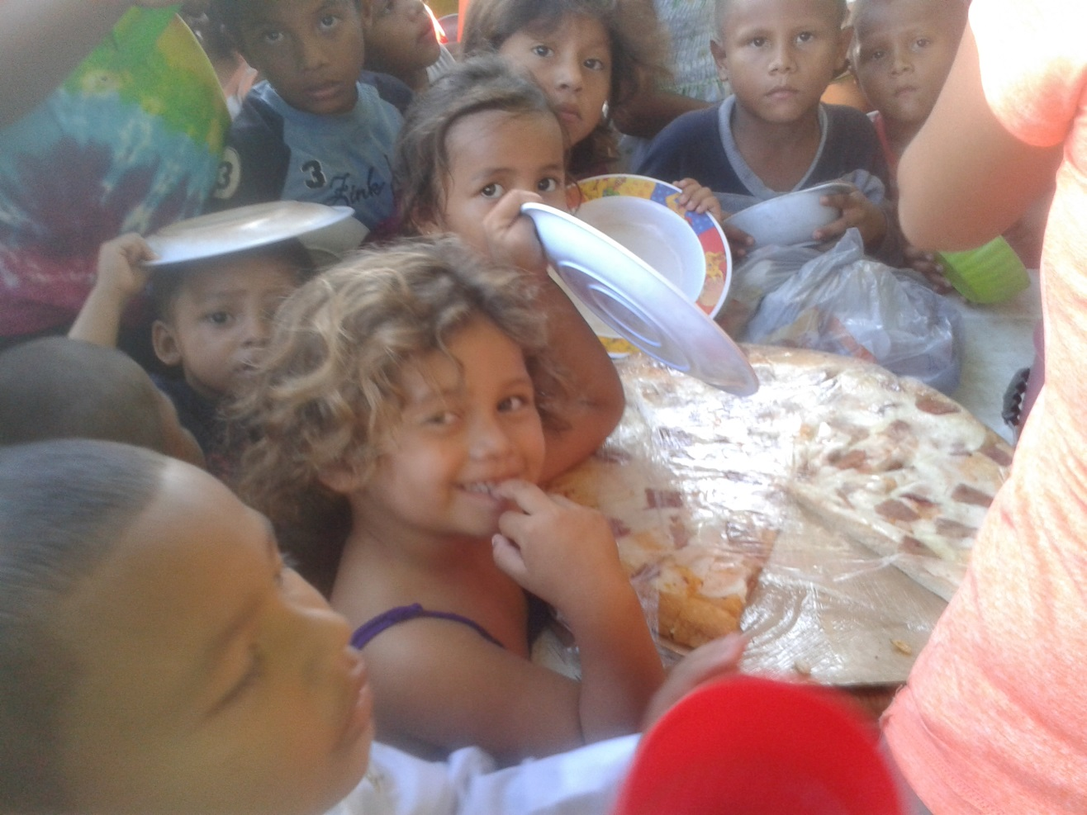
Genesis is the instigator. She has good looks and a quick wit. At the ripe old age of 5, she knows how to use both. It has me on the floor rolling with laughter, while having everyone else kind of upset. Genesis is demanding. Poor guy that marries her! She is going to wear that guy out with her high expectations and limited patience. I truly miss it when she´s not in the food line (which is almost never). She loves junk food. If it´s healthy food, she lets us know. Pizza Frietag (Friday pizza, our pizza day) is her favorite. Very rarely do we serve hot dogs, but when she´s there, she´s one happy camper. She lives in tough environment, as the rest of them do. She will survive, Lord willing. My concern is how. She is a fighter and will do whatever it takes. She has taken down single handedly the biggest bullies on the block, and believe me , there are plenty.
CHINITA KNOWS SHE IS LOVED. Everyone in the barrio loves her. She comes from a good home here, where the mother watches over her and her siblings like a hawk. Her and her siblings are well behaved, quiet and generous. She constantly has a cold, I have no idea why, it is HOT here. She´s had a cold since I have known her. BUT, even though she gets a little baby cranky, she´s totally a pleasure to be around. So are her big sister and big brothers. The family is related to Xochi, my little girl with the skin condition. They all live next door to the feeding center. They have the strongest Mayan features of the whole neighborhood. It´s a fascinating family, and fun to be with.
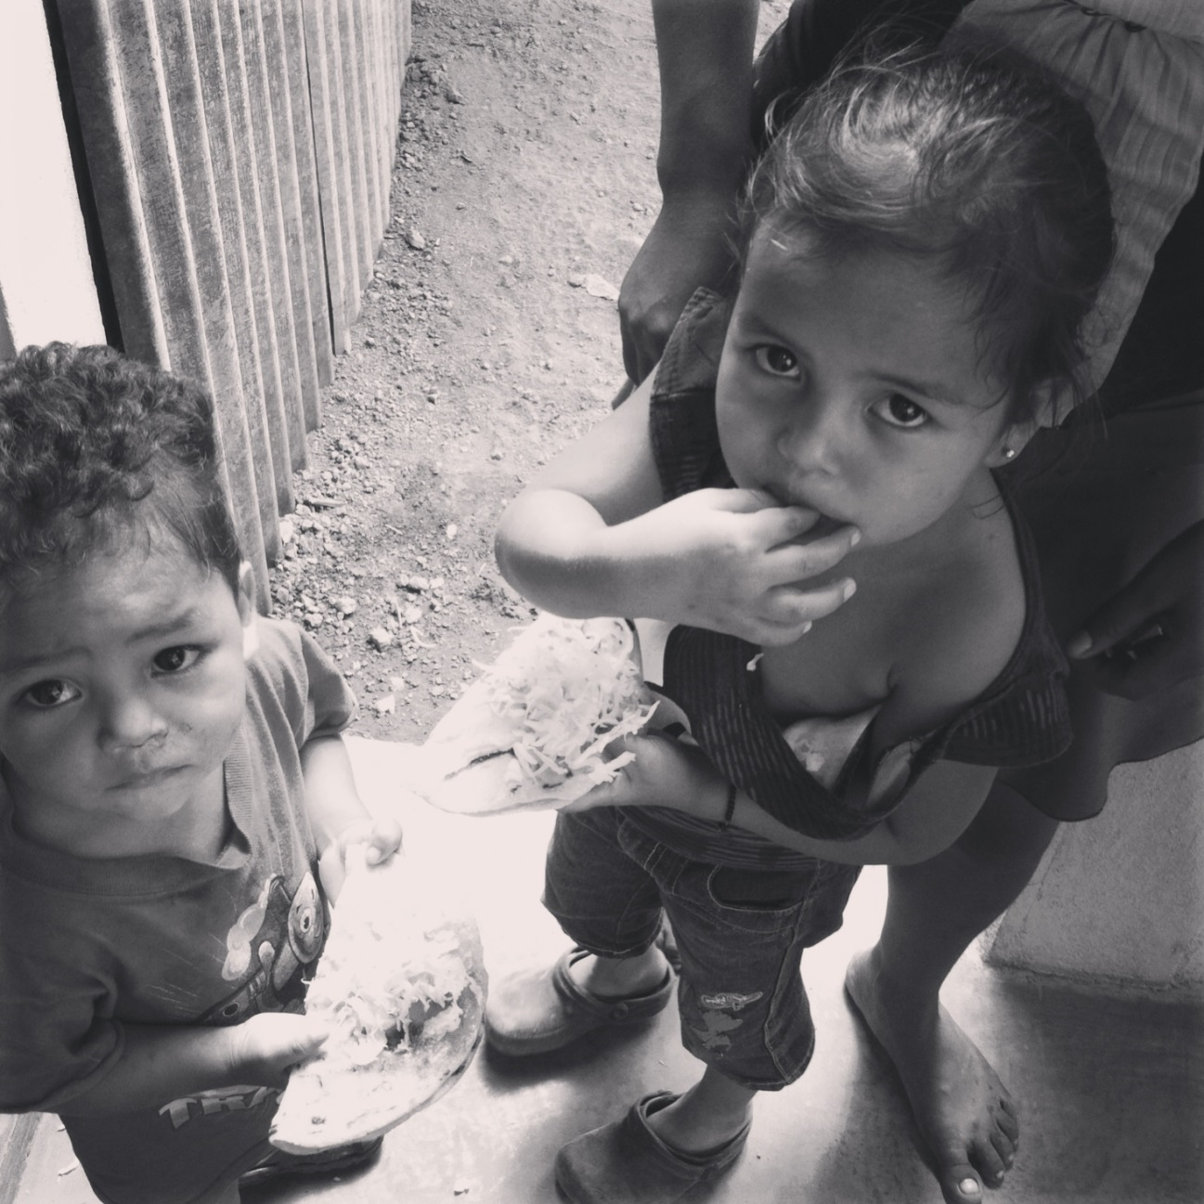
Lisseth is a full time mother. She´s four, and extremely busy. She has a full plate (literally speaking). Her little brother´s 3. She takes care of him, feeds him, and defends him, under the watchful eye of her mother, when her mother isn´t digging out scrap metal from the garbage dump. Lisseth communicates wonderfully all the stuff that little 4 year old girls are concerned about all over the world. But she gets very cranky if she catches me talking to other 4 year old ´guilas´ as she says scornfully. If I talk to other 4 year old girls, I have to be kind of sneaky about it, but she usually catches me and ignores me for a couple of weeks. Hummmmm, I wonder if she´s taking classes from my wife.

